**Credit Default Spread, Country Rating, and Sovereign Debt**

Krishnan Dandapani

RB 209B, Department of Finance

College of Business Administration

Florida International University

11200 SW 8th Street, Miami Florida 33199

Tel: (305)3484225 Email: [dandapan@fiu.edu](mailto:dandapan@fiu.edu)

Edward R. Lawrence

RB 207A, Department of Finance

College of Business Administration

Florida International University

11200 SW 8th Street, Miami FL 33199

Tel: (305) 348-0082 Email: [elawrenc@fiu.edu](mailto:elawrenc@fiu.edu)

Ivan M. Rodriguez, Jr.

RB 236, Department of Finance

College of Business Administration

Florida International University

11200 SW 8th Street, Miami FL 33199

Tel: (305) 348-2680Email: [imrodrig@fiu.edu](mailto:imrodrig@fiu.edu)

**First Draft, Preliminary and Incomplete**

**Pl. do not quote**

**Abstract**

In this study we provide evidence on macroeconomic variables to determine country rating, namely, GDP per capita, external debt as a percentage of export, the level of economic development, default history, real growth rate and inflation rate. Another major contribution of this study is the analysis of the use of CDS to neutralize sovereign debt. Our results, using historic and time series data, could validate the use of credit default spread on sovereign debt which is superior to sovereign bond spread in determining country risk. This could lead to new studies incorporating CDS in determining country risk.

Keywords: Credit Default Spreads, Sovereign Debt, Country risk ratings

**Credit Default Spread, Country Rating, and Sovereign Debt**

**Introduction:**

Over the past twenty years, sovereign debt issued by national governments has grown astronomically and the current debt levels of global nations are staggering. [Chart 1] However, the enhanced leverage levels raise some very troubling questions. How can global investors avoid the vicious cycle of boom and bust of nations which lead to sovereign defaults such as the Russian and Asian crisis of the 1990s and the European crisis of 2000s. How safe are the sovereign debt markets for the global investors? Sovereign defaults have an enormous potential to create a global contagion and causal effects leading to worldwide recession [See Chart II]. Recently, we witnessed the apocalyptic bank run in Cyprus following the restructuring of national debt in Greece. When investors receive a severe haircut in sovereign debt investments such as Ireland, Greece it has a cascading effect leading to an economic downturn. Historically, investors have relied on Credit rating agencies to guide their investment decisions, and rating agencies have played a very crucial role in investor’s decisions in fixed-income market. Ratings are initiated and constantly monitored as economic conditions vary and reflect the expected performance of underlying assets, and probabilities of default. While rating agencies use varied parameters and methodologies in assigning ratings; nevertheless, the ratings of most sovereigns tend to be highly correlated and tend to converge. From a borrower’s perspective, rating affects the cost of borrowing. Ratings downward migration affects adversely whereas the rating upgrades reduces the cost of borrowing. Hence, the determinants of country rating are of crucial interest for both borrower and lender. Ratings serve as an important signal in guiding investor decisions. What factors affect sovereign debt ratings? Some prior researchers, when analyzing ratings find very high correlation between sovereign debt ratings and the country rating. However, the fundamental factors and dynamic linkage mechanism for debt rating and country rating are varied, and evolving.

In this study, building on prior works, as a first step, we explore the linkages between country rating and debt issues of a nation. In the second step, we examine the rigorous relationship between the two different national ratings and whether one has a causal relationship with another. In the third step, we examine whether the newer financial engineering innovation, credit default swap (CDS) could be used as a risk transfer mechanism in minimizing sovereign risk. In an efficient market, the credit default swap should appropriately price and insure against the potential credit risk of reference entity. In a global context, the country rating should be determined by credit default spread on sovereign debt. Hence, we explore the potential determinants of country rating, and evaluate the credit default spread on sovereign debt instead of sovereign bond spreads over treasuries for country rating model which has been the norm prior to evolution of CDS. The sovereign debts financed by national governments are used as reference point.

**Hypothesis**

While there are voluminous works studying the relation between macroeconomic variables and country risk rating, the prior literature is both controversial and contentious.

Our study develops on the earlier methodological work suggested by Canter and Packer (1996) and Afonso (2003).

**TABLE I Data and Description of Variables**

According to Canter and Packer (1996), the variables can be defined as follows;

|  |  |  |  |  |
| --- | --- | --- | --- | --- |
| **Variables** | **Definition** | **Unit of Measurement** | **Data Source** | **Relation** |
| Per Capita Income | GNP per capita | Thousands of dollars | World Bank, Moody’s, FRBNY  estimates | The bigger the tax base of the borrowing country, the greater the country’s ability to repay obligation |
| GDP Growth | Average annual real GDP growth on a year-over-year basis | Percent | World Bank, Moody’s, FRBNY  estimates | High GDP growth eases the government to service its obligation |
| Inflation | Average annual consumer price inflation rate | Percent | World Bank, Moody’s, FRBNY  estimates | The higher inflation, the greater political risk. People are worried about their cost of livings. |
| External Debt | Foreign currency debt relative to exports | Percent | World Bank, Moody’s, FRBNY  estimates | The higher debt burden, the larger risk of default |
| Level of Economic Development | IMF classification as an industrialized country | Indicator variable (Dummy)  1 = industrialized 0 = otherwise | IMF | Same explanation to GDP growth |
| Default History | Default on foreign currency debt | Indicator variable (Dummy)  1 = default 0 = no default | S&P | A country experiencing default in the past is widely perceived as a high credit risk. |
| CDS Spreads | CDS spreads on sovereign debt issued by national country | Basis points | Bloomberg | The greater the liquidity, the wider the CDS spread [Fabozzi et al. (2007)] |
| Moody’s, S&P (on avg. ratings) | Ratings assignment by Moody’s and S&P | B1(B+)=3; Ba3(BB-)=4;  Ba2(BB)=5;..Aaa (AAA)=16 | Moody’s and S&P |  |

The study includes the 39 countries; Argentina, Australia, Austria, Belgium, Brazil, Bulgaria, Chile, China, Colombia, Egypt, France, Germany, Greece, Hungary, Iceland, Indonesia, Ireland, Israel, Italy, Japan, Kazakhstan, Lebanon, Malaysia, Mexico, Peru, Philippine, Poland, Portugal, Russia, Serbia, Slovakia, South Africa, South Korea, Spain, Thailand, Turkey, USA, United Kingdom and Venezuela over the period of April 2004 till December 2012 (Note: The number of countries and period of study are based on the availability of data.)

**Methodology**

The multiple regressions methodology is used to investigate the relative significance of all variables that are identified above as determinants of country rating by analyzing data in terms of cross-section and time series. The t-statistic is used to determine the relative significance of the coefficients as well as the (adjusted) R2 is computed to see how well the variable can detect country ratings. To convert bond ratings into number for regression analysis [initiated by Horrigan (1966) and continuing through Billet (1996)], we use the assignment of numerical values to the Moody’s and Standard and Poor’s ratings as follows: B3/B- = 1, B2/B = 2, and so on through Aaa/AAA = 16. To measure a country’s average rating, the average value between two agencies is calculated. The country rating provided by each agency, the average of country rating and the difference between country ratings provided by agencies separately regress on the explanatory variables in order to examine which dependent variable can be best explained. (The country rating is bounded 1 at lower end and 16 at upper end which makes the use of OLS biased. Check if we should use probit model in this case.)

The multiple regressions for the study are formulated as:



where

|  |  |  |
| --- | --- | --- |
| *RGT* | : | Country rating provided by either Moody’s or S&P,  country rating difference between these 2 rating agencies, and  the average country rating between these 2 rating agencies |
| *CAP* | : | Per capita income |
| *GDP* | : | GDP growth |
| *INF* | : | Inflation |
| *DEBT* | : | External debt |
| *ECO* | : | Indicator for economic development 1 = industrialized 0 = otherwise |
| *DEF* | : | Indicator for default history 1 = default 0 = no default |
| *CDS* | : | CDS spreads on sovereign debt |
| *α* | : | Intercept |
| *ε* | : | Error term |

The study should provide the latest evidence on macroeconomic variables to determine country rating, namely, GDP per capita, external debt as a percentage of export, the level of economic development, default history, real growth rate and inflation rate. Another major contribution of this study is the use of CDS to neutralize sovereign debt. Our results, using historic and time series data, could validate the use of credit default spread on sovereign debt which is superior to sovereign bond spread in determining country risk. This could lead to new studies incorporating CDS in determining country risk.

**Some Selected References**

1. Campbell, J., Taksler, G. *“Equity volatility and corporate bond yields.”* The Journal of Finance, 2003, v58, 2321-2349.
2. Cantor, Richard and Frank Packer. *“Determinants and Impacts of Sovereign Credit Ratings,”* Journal of Fixed Income, 1996, v6 (3, Dec), 76-91.
3. Horrigan, J. “*The Determination of Long-Term Credit Standing with Financial Ratios,”* Empirical Research in Accounting 1966, Journal of Accounting Research 4 (supplement), 1966, 44-62.
4. Hull, John, Mirela Predescu and Alan White. *"The Relationship between Credit Default Swap Spreads, Bond Yields, And Credit Rating Announcements,"* Journal of Banking and Finance, 2004, v29 (11, Nov), 2789-2811.
5. 1, 171–195.
6. Lee, Suk Hun., *“Are the Credit Ratings Assigned by Bankers Based on the Willingness of LDC Borrowers to Repay?”* Journal of Development Economics, 1993a, Vol. 40, 349-359
7. Oral, Muhittin, Ossama Kettanti, Jean-Claude Cosset, and Mohamed Daouas, *“An Estimation Model of Country Risk Rating,”* International Journal of Forecasting, 1992, Vol. 8, No. 4, 583-593.
8. Weigel, Diana Diaz and Gordon Genmill. *"What Drives Credit Risk in Emerging Markets? The Roles of Country Fundamentals and Market Co-Movements,"* Journal of International Money and Finance, 2006, v25 (3, Apr), 476-502.

CHART I: SELECT COUNTRIES SOVEREIGN DEBT

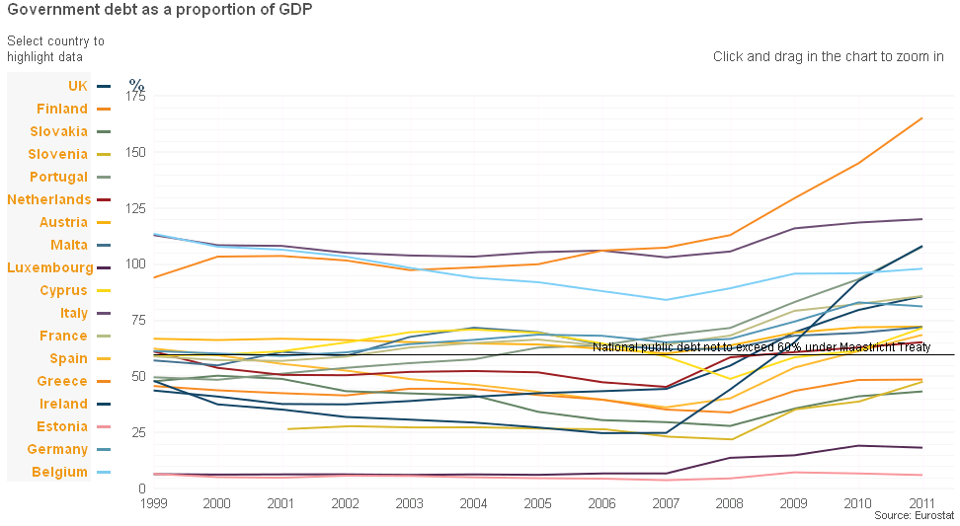

CHART II: SOVEREIGN DEBT AND CONTAGION POTENTIAL

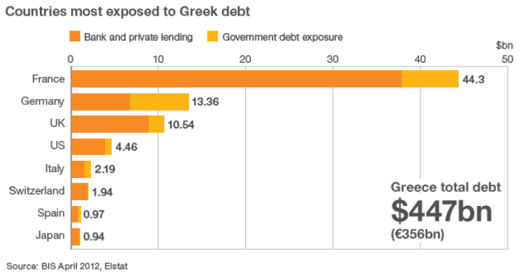

CHART III: SELECT EUROPEAN CDS SPREAD

